Chapter 11, Problem 28.

Find the rms value of the voltage waveform of Fig. 11.59 as well as the average power absorbed by a 2-Ω resistor when the voltage is applied across that resistor.

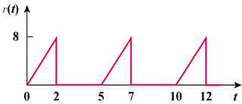

Figure 11.59
For Prob. 11.28.

